***ASSIGNMENT-1(NALAIYA THIRAN)***

***SMART HOME DESIGN USING TINKERCAD***

***TEAM MEMBER 3 : NARMATHA S***

***REGISTER NUMBER:720319106701***

***SCHEMATIC(CIRCUIT DIAGRAM)***

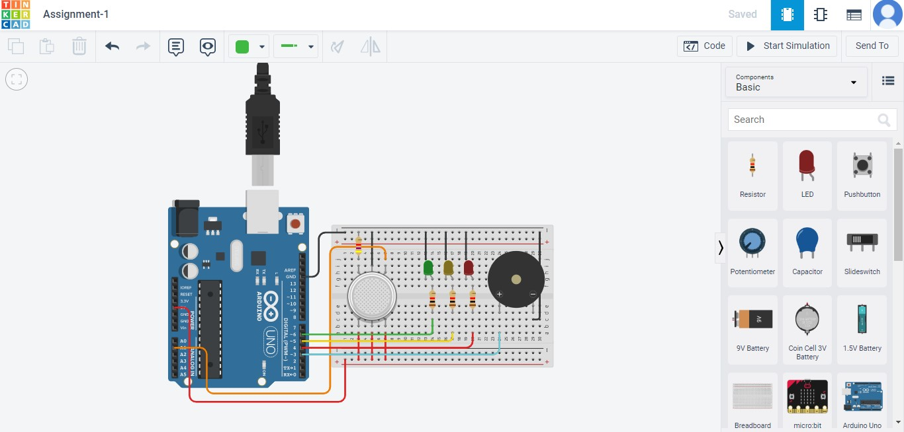 ***CODING:***

int const PIN_SGAS = A1; int LED_green = 6; int LED_yellow = 5; int LED_red = 4; int buzzer = 3; void setup(){ pinMode(LED_green, OUTPUT); pinMode(LED_yellow, OUTPUT); pinMode(LED_red, OUTPUT); pinMode(buzzer, OUTPUT); Serial.begin(9600);

}

void loop()

{

int value = analogRead(PIN_SGAS); value = map(value, 300, 750, 0, 100); if(value < 30){ digitalWrite(LED_green, HIGH); digitalWrite(LED_yellow, LOW ); digitalWrite(LED_red, LOW ); digitalWrite(buzzer, LOW );

}

else if(value >= 30 & value < 50){ digitalWrite(LED_yellow, HIGH ); digitalWrite(LED_red, LOW); digitalWrite(LED_green, LOW ); digitalWrite(buzzer, LOW );

} else {

digitalWrite(LED_red, HIGH ); digitalWrite(LED_yellow, LOW ); digitalWrite(LED_green, LOW ); tone(buzzer, 500); delay(300); noTone(buzzer); delay(50);

}

delay(250);

}